A Twitter Guide, for Montréal à Votre Service Écologique
By Carly Ziter (@CarlyZiter)
Twitter is a form of online social networking based on the idea of “microblogging”. Users, each represented by a twitter handle (ours is @ESMontreal) can send out 140 character “tweets” (similar to text messages) that are available to the public. The following guide is meant as a breakdown of getting started with twitter, and some tips and tricks to help you along!
Table of Contents
- Twitter Interface
  - Home
  - @Connect
  - #Discover
  - Me
- How to Tweet
- Twitter Interactions
  - Replying
  - Retweeting
  - Favouriting
- Hashtags
  - Temporary Hashtags
  - Ongoing/continuous hashtags
  - The dual nature of hashtags
- Staying Organized!
  - Lists
  - Tweeting apps
- General Tips and Tricks
  - Staying in character
  - Maximizing your reach
  - Keeping it short
  - Dealing with mistakes
  - Self Promotion
- Livetweeting
- Storify

First, a cautionary note: As with the internet in general, when you tweet you are putting information out there – and have no way of knowing how far it will go or who will see it. Don’t say anything inappropriate, or that will reflect badly on you or the group. If you find yourself wondering whether what you want to tweet is ok, it probably isn’t. Set it aside for a day or have someone else take a look. You want to have fun with twitter, but above all, you need to be respectful. Here’s one example of what not to do.
- Twitter Interface
A breakdown of the Twitter top bar: Home, @Connect, #Discover, Me
  - Home
On the twitter website the default, or Home interface once you have set up an account looks something like this:
Home interface, from twitter user @ESMontreal
This is the view from the Home page (chosen at the top left of the top bar). Choosing Home brings you to your personal twitter feed. On the upper left hand side, there is a panel including your icon, and name (e.g. our ESMontreal logo, and EcoServices Montreal). Underneath there are 3 headings: Tweets, Following, and Followers.
At the time this screenshot was taken, you can see that we have tweeted 428 times (or sent out 428 messages).

We are following 97 other twitter users, which means we see all of the tweets from those 97 users in our twitter feed. These tweets show up on the right hand column in the figure above (our feed), in reverse chronological order. So, for example, we can see that science journalist Bora Zivkovic (@BoraZ), who we follow, has tweeted 1 minute ago, and Guardian Environment tweeted 1 minute prior to that.

We have 103 followers, which means 103 other twitter users subscribe to our tweets. Tweets that we post shows up in their twitter feeds, on their home pages.
Note that on twitter, followers (users who follow you) and users that you are following are a one-way street. Just because you choose to follow someone, and subscribe to their tweets, this does not mean that they see any of your tweets unless they explicitly follow you back.
  - @Connect
The @Connect interface shows all of your interactions with other twitter users.
@Connect interface, from twitter user @ESMontreal
Interactions may be favourites, retweets, or mentions (more on each of these in section 3. Twitter Interactions). Your interactions let you know who is responding to your tweets, sharing your tweets, tweeting something specifically to you, or favouriting (like bookmarking) your tweets. This page gives you an idea of the audience you are reaching, and allows you to notice users who you may want to interact with.
  - #Discover
The #Discover interface (not shown), displays tweets that are tailored to your interests, based on who you follow and interact with on twitter – for a new twitter user, this page is likely going to be less important than your Home and @Connect pages.
  - Me
Finally, the Me interface shows your twitter page as others see it
Me interface, from twitter user @ESMontreal
This shows your icon that others see when you tweet (our logo), your name (EcoServices Montreal), your twitter handle (@ESMontreal) that users use to tweet to you, and a brief bio, or description of who you are/what you tweet about. A feed of just your own tweets is also shown on this page. From here, you can also navigate (using the menu on the top left) to pages showing your followers, who you are following, tweets that you have favourited, and users that you have organized into lists (See more in section 3. Twitter Interactions, and section 5.1 Lists)
- How to Tweet
Okay, now that you’ve got the basic interface down, how do you actually start tweeting?
There are two main ways to tweet on the twitter webpage:
- From your Home page, there is an empty field labeled “compose new tweet…” in the upper left panel (right underneath the tweets, following, followers headings).
- On the far right of the top bar, there is a small blue icon . Clicking this icon will open a text field from which you can tweet.
To tweet, simply type your message into the field. On the bottom right, there is a countdown of your remaining characters (remember, you only get 140!). You can also add links, or photos to your tweets (to add photos, click on the camera icon in the bottom left). When you are satisfied with your tweet, click the blue “tweet” button on the bottom right.
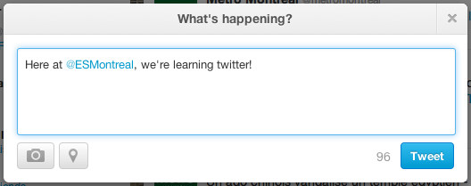
Tweeting field, from twitter user @ESMontreal
Note: You can also Direct Message, or DM, someone rather than tweeting to all of your followers (if you are familiar with facebook, this is comparable to a private message, rather than a wall post). You are still limited to 140 characters, but nobody will be able to see this tweet other than the person you are sending it to. To send a direct message, use the dropdown menu (the small wheel icon in the top bar, to the right of the search bar), and choose “Direct Message”.
- Twitter Interactions (retweeting, replying, etc.)
Often, you will want to respond to, or share, something that someone else has tweeted. Social interactions are a big part of twitter. There are various methods of doing this. I’ll outline a few of the common ones, and the appropriate syntax to go with them, below, using this tweet of Chris Buddle’s as an example:
Tweet from twitter user @CMBuddle
If you hover over Chris’ tweet with your mouse, or click on it, you’ll see a menu come up beneath the text of the tweet that looks like this (in light blue):
Tweet from twitter user @CMBuddle
The main interactions on twitter are: Reply, Retweet, Favourite. I’ll discuss them each below.

  - Replying
To reply to a tweet, simply click on the reply option. Chris’s handle, @CMBuddle, will appear in the response field… simply type your message after it. This tweet will show up in your feed like all of your tweets, and will also show up in Chris’ @Connect interface, so he’ll know that someone has responded to his tweet.
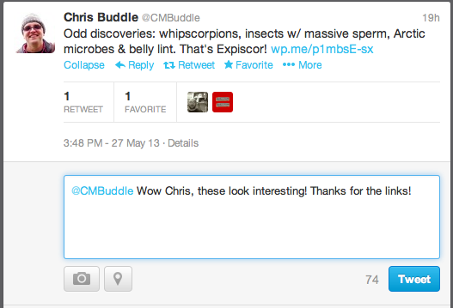
Tweet from twitter user @CMBuddle
Warning: If you START your tweet with someone’s twitter handle (e.g. staring with @CMBuddle, above), the only people who see this tweet in their feeds are those who follow both you and Chris. That is, someone who follows only you, but not the user you are replying to, will not see this tweet in their regular feed. If you would like the tweet to be easily seen by all of your followers, you can rephrase (e.g. in this case, we could tweet “Wow @CMBuddle, these look interesting!...”), or you can simply add a period before the handle (e.g. “.@CMBuddle Wow Chris, these…”)
  - Retweeting
Retweeting gets a little more complicated – there are multiple ways of retweeting, or sharing, someone else’s tweet:
- Direct retweets. If you see a tweet that you would like to share with your followers as is, you can retweet it (without any alterations) by choosing the retweet option. The tweet will now be broadcast to all of your followers, exactly as it appeared. You are acting as a middleman in this situation, forwarding the tweet on to more people on behalf of the original tweeter.
- Indirect retweets (i.e. using RT, or “ ”): Sometimes, you want to add something of your own to somebody else’s tweet before re-posting it. You can also retweet by using the syntax “RT”, and copying the tweet, while writing your own tweet as usual. This allows you to add your own thoughts, while still giving appropriate credit for the tweet. Simply type “RT” followed by the handle of the user you are retweeting, and then their original tweet (note: some people forego the “RT”, and just surround the text in quotes. That’s fine too).
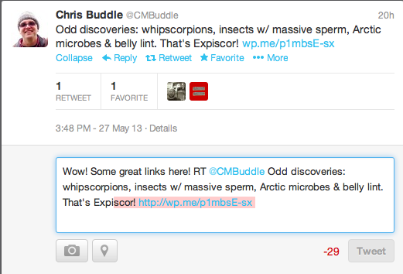
Tweet from twitter user @CMBuddle
Notice that in this case, adding our thoughts and retweeting makes our tweet too long! (see the red highlighting and the -29… we’ve gone over the limit by 29 characters! Uh oh!) In this case, we can use what is called a modified tweet
- Modified tweet (using “MT”): if you are shortening, summarizing, or otherwise changing someone’s original tweet, you can use “MT”, instead of “RT”. Often, this is done to shorten a tweet and save characters, or to emphasize one part of a tweet. For example, the tweet above could be written as follows:
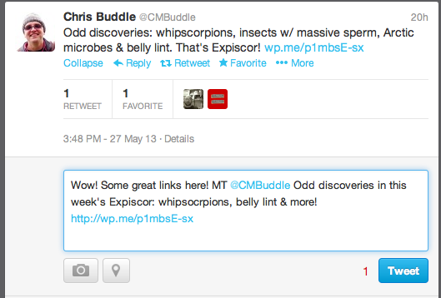
Tweet from twitter user @CMBuddle
We’ve kept the original tone and information of the tweet, but altered the exact wording – which we are informing readers of via the “MT” (Think of this like paraphrasing someone’s work, compared to directly quoting it). This tweet would then show up in our feed like this
Tweet from twitter user @ESMontreal
- Other common methods of acknowledgement:
It is important to always acknowledge where you got your source from – twitter may be informal, but it is still wrong to plagiarize the work or ideas of others!
If the information in your tweet came from someone else, but you aren’t using enough of their tweet to justify using a RT or MT (for example, you are just sharing a link from someone else), you can simply credit them at the end, using “via @twitterhandle”, or even “HT” (For “hat tip”, or “heard through”).
Example:
Tweet from twitter user @ESMontreal
Here, we are writing our own tweet, but also acknowledging that we got the link from Chris, and that it is his blog we are referencing.
Note: These are among the most commonly used forms of acknowledgement, but they’re not the only ones out there – just make sure to give credit where credit is due, in whatever way works for you!
  - Favouriting
This one’s simple, see a tweet you love, or that you want to revisit later? Click favourite, and the tweet will be bookmarked for future reference. The user who sent the tweet will see that you have favourited it on their @Connect page.
- Hashtags
The hashtag, or # is a very common tool on twitter. The hashtag’s main use is as a cataloguing or grouping mechanism. So, one can search for a particular hashtag (using the search bar, at the top right of the twitter top bar) and see all the tweets that have included it. Adding a hashtag allows your tweet to travel beyond just your own network, and is a great way to connect with others on twitter if used wisely. Hashtags can be incorporated right into your tweet (e.g. “Saw some beautiful #trees exploring Montreal’s #urbanforest on Mont Royal today”) or you can put them separately, at the end of your tweet (e.g. “Saw some beautiful trees exploring Montreal’s Mont Royal today! #trees #urbanforest”). Hashtags are especially important for things like livetweeting, or storify (See sections 7, 8.).
  - Temporary Hashtags
Some hashtags are temporary, for example, conferences will often have a specific hashtag to facilitate gathering all tweets related to that specific conference in the same place. This could be something like #esa2013 for all tweets related to the Ecological Society of America (ESA) conference.
Other examples of temporary hashtags might relate to a current event in the media, for example the #MooreOklahoma hashtag was used for tweets related to the recent tornado, or a current campaign that an organization is promoting, like the David Suzuki Foundation’s recent #30x30Challenge.
  - Ongoing/Continuous Hashtags
Some hashtags are ongoing, and are related to the topic/content of a tweet, rather than a specific phenomenon or event. For example, #scicomm is commonly added to tweets about science communication, and #phdchat is commonly used in tweets related to grad school. Even more general topics often have hashtags as well (for example #forest, #ocean, or #birding).
  - The Dual Nature of Hashtags
Hashtags also have a more whimsical side, where people will use them as a humorous addition to a tweet, not as a serious grouping mechanism. For example, these #MacroMatrimony, or #HiggsBison, hashtags are meant to be humorous, not a serious tool:
Tweet from twitter user @BioInFocus
Tweet from twitter user @blogscience
Sometimes, there is overlap between this dual nature of humorous hashtags vs. actual grouping mechanisms, for example the #overlyhonestmethods hashtag. Originally part of a funny tweet, the hashtag has caught on, and become a major twitter phenomenon among researchers & scientists.
- Staying Organized on Twitter!
  - Lists
When you are following many people (sometimes hundreds, or even thousands!) on twitter, it can be very easy for tweets to get lost in the endless stream of your twitter feed. Twitter lists are a way to organize your followers into groups – a great way to keep track of followers whose tweets you don't want to miss. For example, for ESMontreal, we might have a list of scientists, or a list of potential stakeholders and organizations. Each list will similar in appearance to your normal twitter stream, but will contain only the tweets of the listed users. To create a list, navigate to your Me interface, and choose Lists from the menu on the top left panel. Here, you will see an interface containing lists that you are subscribed to, or a member of.
Below, you can see that Carly is member of various lists – that is, other twitter users have added her to those lists. Toggling to the subscribed to option will show lists that you personally follow. You can create your own list (by choosing the create list option on the top right), or subscribe to lists that other people have created. For example, by clicking on Colin Schultz’ “Emerging Can Sci Comm” list, I can see the feed of tweets from this list, and choose whether or not to subscribe (subscribing to a list is like bookmarking it, so you can easily navigate back to it in your Lists option in the Me interface).
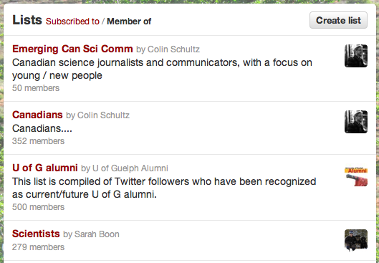
List interface from twitter user @CarlyZiter
  - Tweeting apps
Another great organizational tool is using twitter through a tweeting app, rather than the twitter website. There are several (both third party and twitter owned) tweeting apps that you can use to manage your twitter account, for the more serious user. (e.g., TweetDeck, HootSuite, etc). This is a much more streamlined way to use twitter, often with the option to have multiple columns (for example, rather than having to toggle back and forth between the Home, @Connect, and Me interfaces, you could simply have a column of your tweets, a column of interactions, and a column for your twitterfeed, or a particular list). Apps are also particularly useful if you’re managing multiple twitter accounts, and want to be able to tweet from both without logging in and out each time (for example, you can choose to tweet from your own account, or the ESMontreal account, without having to sign in and out of an account to do so). A few examples of commonly used apps are Tweetdeck, or Hootsuite. You can find several reviews of the strengths and weaknesses of different apps online, to choose the one that best meets your needs.
Here are a few links to reviews of twitter applications and other social media tools:
http://webtrends.about.com/od/pr6/tp/The-Top-10-Social-Media-Management-Applications.htm
http://www.citeworld.com/social/21771/tweetdeck-alternatives-review?page=0
http://blog.kissmetrics.com/10-twitter-tools/
- General Tips and Tricks
  - Staying in Character
Often, twitter users will have a particular “style”, or tone. Some people tweet very matter-of-factly, while some are humorous, for example. Cultivating an engaging personality on twitter can help you gain, and retain, followers. Adding some personality to your tweets can also help get your tweets retweeted, reaching a much larger audience. A great example of tweeting in character is the Curiosity Rover account (@MarsCuriosity), the official account of NASA’s Mars rover. The women behind the account decided to tweet in the first person, and the tweets are full of twitter slang (“tweetspeak”), attitude, and pop culture references. Check out this article for more on that: http://www.forbes.com/sites/alexknapp/2012/08/10/the-women-whove-transformed-a-mars-rover-into-a-sassy-social-superstar/
Maintaining a consistent character, or personality, can be hard with multiple-user accounts, but it’s important! Think of it like keeping your writing style consistent in a multi-authored paper, or giving a group presentation that flows well. At @ESMontreal, the goal is to keep the tweets informative, but also informal, and excited. The idea is that we’re doing something really cool, and we want to share it! We’ve got style! We’ve got personality! Yes, we want to make sure the information we share with our followers is interesting and relevant, but we also don’t want to alienate our target audience (Montrealers!) with jargon, or boring statements. We want to tweet things in a way that is fun and catchy. When you tweet, think of how you might phrase an excited email to a friend, or address a classroom full of young and curious students, rather than a formal paper or memo.
For example, instead of tweeting:
“We visited the MacDonald Community gardens today”,
we might tweet something like:
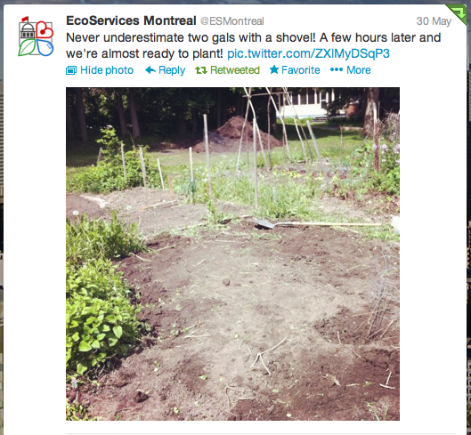

Tweet from twitter user @ESMontreal
We know that people are drawn in by stories, especially with a personal touch – that’s why we’re all about storytelling here at ESMontreal. Don’t be afraid to tweet in a personal tone, or about real people. Engage with your followers! Tweets explicitly addressing a group of people can be really engaging, as can tweeting about what our team members are doing. Check out these examples:
Instead of tweeting: “The @McGillU bird observatory is located at the Macdonald Campus”, we can say:
Tweet from twitter user @ESMontreal
Instead of simply saying “Today we filmed a video blog at the bird observatory”, the following tweet engages with other users in a fun way, while also letting people know the kind of stuff we’re up to:
Tweet from twitter user @ESMontreal
We have lots of team members who are also active twitter users – we can use that to our advantage in our tweets (read more in section 6.2. Maximizing your reach).
Also, don’t be afraid to use pop-culture references or tweet jokingly once in a while. Our followers loved this one (who doesn’t love a little Jay Z?)
Tweet from twitter user @ESMontreal
  - Maximizing your reach (i.e. multiple account tweeting)
Using multiple twitter accounts can spread your message much further. This can be as simple as ESMontreal members retweeting our tweets from their individual accounts, or the opposite, if our members tweet relevant things to @ESMontreal from their own accounts, we can retweet them or modify and share them from our account. Spreading the message this way can reach many more people. Planning out “conversations” like this can also create a fun dynamic – our followers don’t necessarily know which users are affiliated with @ESMontreal, so from their perspective, we’re doing a great job of reaching out and interacting with other users. For a good example of maximizing outreach through multiple related users, check out Jonathan Foley’s twitter stream (@GlobalEcoGuy). He often retweets or shares similar information to Ensia magazine (@ensiamedia), and the Institute on the Environment at the University of Minnesota (@UMNIonE), which are all affiliated.
  - Keeping it short
Unlike this guide, tweets are short! Conciseness is key – but getting your point across in 140 characters can be tricky. Practice makes perfect (or at least, pretty good), but there are some tricks you can use to shorten your tweets.
- As long as they are recognizable (either through common usage, or context), using short forms where possible can cut down on characters (e.g. “Prof” instead of professor, “Tmrw” instead of tomorrow.
- Consider whether symbols can be used for words (e.g. “&” instead of “and”, “#” instead of “number”)
- Use hashtags strategically. (e.g. If writing about science communication, use #SciComm, instead of “Science Communication”).
Careful: if you find yourself replacing every other word with a short form or a symbol, your tweet is probably just too long. If possible, rephrase it entirely to fit within 140 characters. If you just have too much to say, consider using 2 tweets. Make sure to use 1/2, and 2/2 at the end of your tweets, respectively, to let your readers know that they’re part of a sequence. Also, you should never shorten a tweet at the expense of acknowledging someone. The 2-tweet method can also be used in these cases, if necessary. Tweet what you’d like to say, and then immediately following, tweet something like “last tweet via @twitteruser’s great article!”. Although, do note that the point of twitter is of course “microblogging”, so if you find that you’re needing 2 or 3 tweets for all of your messages, you probably need to reframe your thinking of how to tweet effectively.
Here’s an example of a long tweet, and a shorter, more effective version (note the incorporation of hashtags)
Long tweet (29 characters over limit):
“McGill University professors @ElenaBennett and @CMBuddle are both great examples of strong science communicators who use social media tools to engage in science outreach”
Shorter, more effective tweet:
“Follow @McGillU profs @ElenaBennett, @CMBuddle for great examples of strong #SciComm on twitter! #ff #reachingoutsci”
  - Dealing with Mistakes
Uh Oh! You've tweeted something incorrect (maybe you used the wrong twitter handle, made a typo, or stated a fact incorrectly), and now it’s out there for the world to see! What do you do?
Here are some options:
- Delete it. You can delete tweets by hovering over the tweet and choosing “Delete” from the menu under the tweet. Consider deleting if you have noticed your mistake quickly, and wish to replace it.
- Correct it – in a new tweet. If your tweet has been published for a while (and especially if others have already commented on it or retweeted it), some believe it is better etiquette to simply post a correction than to delete the incorrect tweet. This is similar to the practice of using a strikethrough in a blog to correct a previously wrong statement.
- Laugh it off. This is similar to correcting your tweet. Did you make an embarrassing spelling or numerical mistake? Instead of rushing to delete and repost, why not just post a new tweet laughing about the mistake (“re: last tweet…Long day at the office today! Obviously meant 100Mg/ha, not 1000! #oops”).
Of course, it’s ultimately up to you, the user. If you’d prefer to delete and re-tweet, then do so, but know that others may have already seen what you posted, and may be confused when it suddenly changes or is no longer there. A general rule of thumb I like to follow is to delete mistakes when I catch them immediately and nobody has interacted with the tweet, but to re-post a correction when there is a high likelihood the tweet has already been read, or somebody has responded to it.
  - Self Promotion
Often, you may want to use twitter to promote another piece of work. For example, at @ESMontreal, we’ll use our twitter account to share our stories and website more broadly. Some rules of thumb:
- When a story first comes out, tweet about it! Be sure to maximize your reach by (re)tweeting from multiple accounts, if possible! Remember to stay in character, and keep the tweets exciting and engaging – don’t just tweet the title.
- Tweet it at least twice. Later in the day, or the following day, tweet it a second time. If you want, you can preface this tweet with an “In case you missed it…”.
- If retweeting more than twice, try and tweet about it from a different angle. Already tweeted a story, but still want to get the word out there? Tweet the link again but using different wording – remember, you want to get as many people to read it as possible, not everyone will be interested in the same aspects of the story.
- Retweet old stories periodically. This is especially useful if there a timely connection (is it raining out? Then retweet the link to that story about rainstorms… Is it harvesting season? Tweet a “flash back” to the early season story about planting). Did Gen just author another story? Remind users of Gen’s last story.
You may feel like you’re bombarding people with the same thing over and over, but remember that each tweet is appearing as a quick blip in someone’s timeline, soon to be buried by other tweets – don’t let your tweets get lost! Chances are many of your followers will only catch one out of several tweets. Check out Jonathan Foley (@GlobalEcoGuy) for a good example of re-sharing information.

- Livetweeting
The phenomenon of livetweeting, or tweeting about an event as it happens, has grown in popularity among the academic community lately. Livetweeting is now common at conferences, where audience members will livetweet talks as they occur – so others who are interested can tune in from afar. How do we follow a livetweeted talk? Using hashtags, of course! It’s important to consistently add a specific hashtag to all of the tweets in a livetweeting session so that others can track them.
Here’s a more thorough explanation of livetweeting: https://dev.twitter.com/media/live-tweeting
- Storify
Storify is a tool that allows you to group tweets (or other social media) into one convenient place. Often, people will Storify discussions on twitter (again, often under a certain hashtag), or events that have been livetweeted so that they can be easily revisited in one place. Here’s an example of a Storify by Carly of a livetweeted workshop at a McGill biology retreat: http://storify.com/cziter/graphical-design-for-publications-and-your-researc (note the consistent hashtag used throughout)
Overall, just have fun with it! Twitter is a great way to make new connections, meet new friends, and access information you may never have stumbled upon otherwise. The best way to learn is just to create an account, dive in, and get tweeting!

